1. Name three ways EF Core loads related data into navigation type properties.

Eager, Explicit, and lazy

1. What is meant by Eager Loading?

When a query for one type of entity also loads all its related entities.

1. What two methods are used when doing Eager Loading?

Include and ThenInclude Methods.

1. When using the Load method during Eager Loading, what is meant by “fixes up”?

“fixes up” means that EF Core automatically populates properties.

1. Define the basic difference between Eager and Explicit Loading.

Explicit must specify what navigation properties should be loaded while Eager will load all possible navigation properties when read.

1. What kind of loading was used to display Course entities and the department name they belong to?

Eager loading

1. Do a screen print showing some Courses (make sure department names are showing).

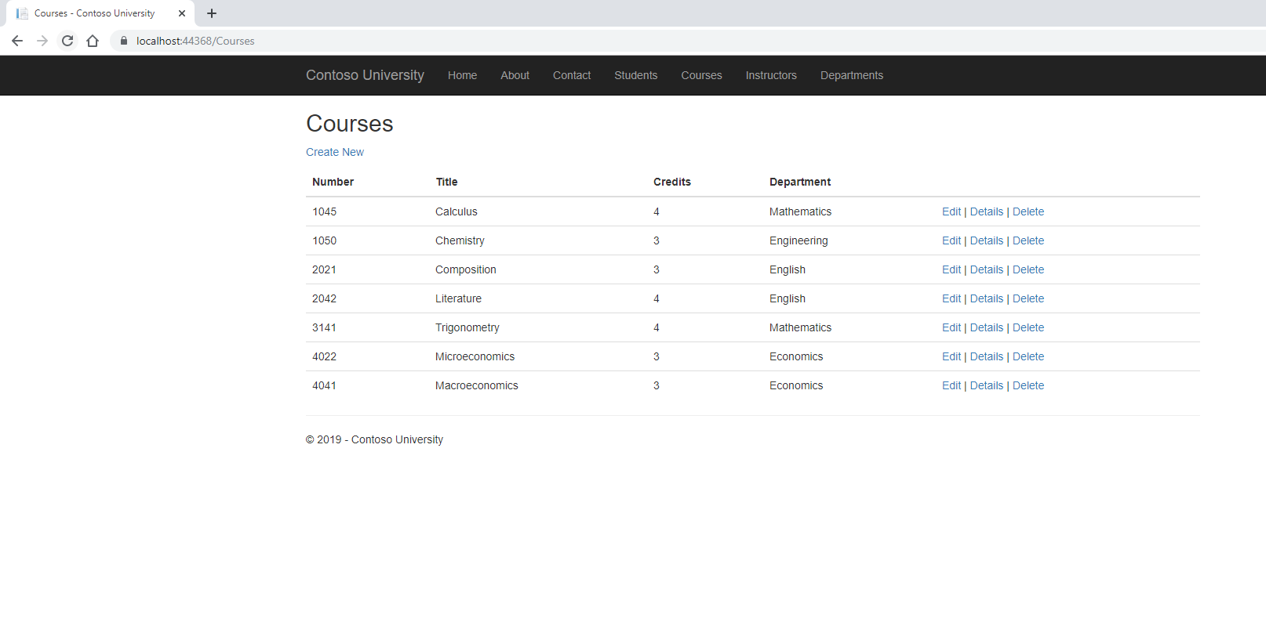

1. In order to show data from multiple tables on a single web page, what was created?

An instructor index view model.

1. What was the purpose of using Bootstrap in this segment?

To set a background color to a tr element

1. Do a screen print showing Instructors along with related Courses and Students.

